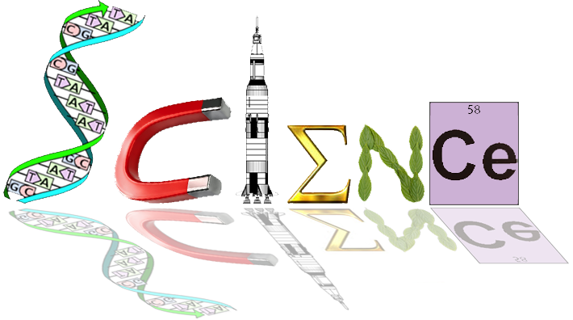

# Task 10: Practical skills investigation

DNA profiling of a Chimpanzee troop

**(20 marks)**

DNA profiling is a process that uses DNA to show relatedness or identity of individual humans, plants, or animals. It is used in forensics, anthropology, and conservation biology not only to determine the identity of individuals but also to determine relatedness. This process has been used to free innocent suspects, reunite children with their relatives, identify stolen animals, and prove that whale meat has been substituted for fish in sushi. It is used in times of war to help identify the remains of soldiers killed in combat. It is also being used to find genetic linkages to inherited diseases. In addition, scientists are learning a great deal about our evolutionary history from DNA analysis.

**The Scenario:**

For three years a team of researchers have been watching three different Chimpanzee troops in equatorial Congo. They are especially interested in the genetic diversity of these Chimps. As the numbers of chimpanzees are decreasing, determining the genetic diversity of these populations is increasingly important. In particular, this team is interested in identifying the parents of one of the new baby Chimps, Kara. Through their observations of nursing behaviour they have matched Kara with her mother; however, none of their observations have helped them link Kara to her father. Today you are going to help them figure this out!

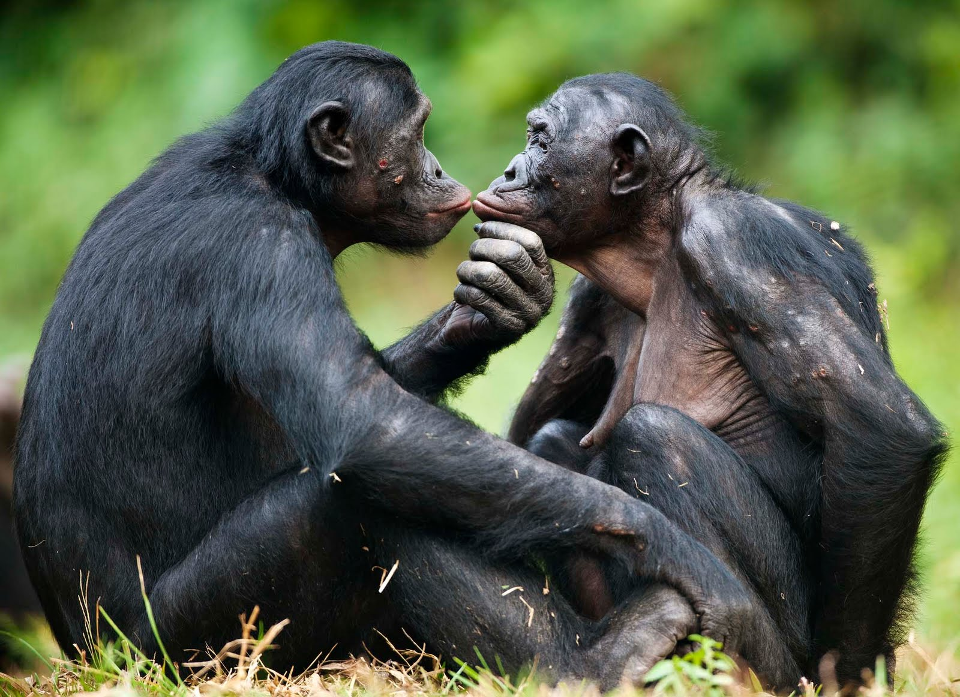

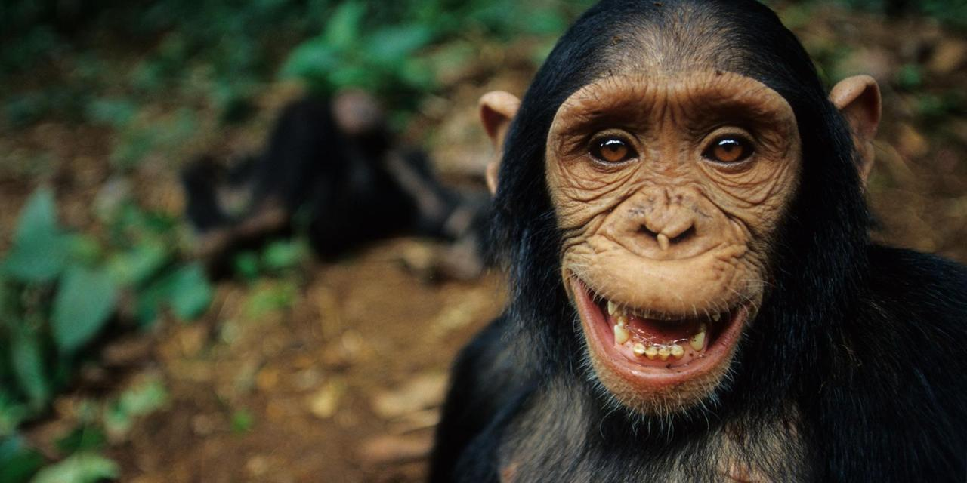

**Chimpanzee troop Information:**

|  |  |  |
| --- | --- | --- |
| Pod | Gender | DNA sample |
| 1 | Female (mother) | 1 |
| 1 | Female (Kara) | 2 |
| 1 | Male A | 3 |
| 2 | Male B | 4 |

**Materials**

DNA from Mother (1), Kara (2), and the two male Chimps (3 and 4)

Gel electrophoresis apparatus and power supply

**Procedure:**

1. Place Agar Gel tray with the wells orientated to the Negative terminal in the unit.
2. Pour Buffer into tank (not directly onto gel) so that terminals are covered as well as the top of the gel.
3. Using a micropipette add the samples to the wells, recording what one is where, one at a time, cleaning the apparatus in between. Space the samples out evenly to make reading data easier.
4. Replace Lid to unit, check sister group is also ready, call teacher over to check, once given approval switch power on.
5. Set unit to 100V for 20min.
6. If bubbles are not visible, call teacher over to check unit.
7. After 20min remove gel tray and draw results and complete questions.

**Results:**

1. Draw a picture of your gel and label, which samples are where before you add DNA to the gel.

(1 mark)

**Analysing the DNA data**

After the DNA has sufficiently separated turn off the power and carefully remove the gel.

1. Draw a picture of your stained gel; be as accurate as possible in drawing the bands. (consider distance and colour) (2 marks)

**Conclusion**

1. As Lead Biologist on the expedition you have a strong suspicion that the Male in Sample B is the father. Write a Hypothesis for this experiment reflecting this. (2 marks)

1. What can your data tell you about which male is Kara's father? Explain. (5 marks)

4. How accurate and reliable are these results? Explain. (2 marks)

4. Describe some limitations of using this method of DNA profiling. (2 marks)

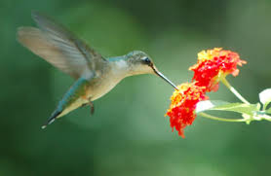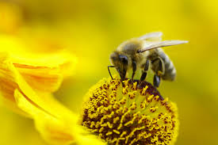5. Evaluate the utility of this type of DNA profiling for two of its uses. (3 marks)

6. Practical Skill component (Group Mark) (3 marks)